**SOFTWARE REQUIREMENTS SPECIFICATION**

***for***

**YCNB**

***Prepared By***

**YAHYA GÜNGÖRÜR**

**CEYDA EREN**

**NESLİHAN AK**

**BESTE DENİZ**

06.11.2018

CHANGE HISTORY

|  |  |  |  |  |
| --- | --- | --- | --- | --- |
| Data Document | Version | File Name | Format | Status |
| 30.11.2018 | 1.0 | A.S-SRS-v1.0 | MS Word 2017 | Created |

PREFACE

The document contains the Initial Plan of ARTİCLE SYSTEM. The mission of the project is a web-based. The Goal of the initial plan is to describe overall picture of theARTICLE SYSTEM.

**TABLE OF CONTENTS**

CHANGE HISTORY i

PREFACE ii

LIST OF FIGURES v

LIST OF TABLES vi

[1 INTRODUCTION (Section 1 of the SRS) 1](#_INTRODUCTION (Section 1 of the SRS))

[**1.1 Purpose of the SRS 1**](#_Purpose of the SRS)

[**1.2 Scope of the Product 1**](#_Scope of the Product)

[**1.3 Definitions, acronyms and abbreviations 1**](#_Definitions, acronyms and abbreviations)

**1.4 References 2**

**1.5 Overview 2**

[2 OVERALL DESCRIPTION (Section 2 of the SRS) 3](#_OVERALL DESCRIPTION (Section 2 of the SRS))

[**2.1 Product perspective 3**](#_System interfaces)

[**2.1.1 System interfaces 3**](#_System interfaces)**(FAILURE! SOFTWARE NAME WRONG)**

[**2.1.2 User interfaces 3**](#_User interfaces)**(FAILURE! SOFTWARE NAME WRONG)**

**2**[**.1.3 Hardware interfaces 4**](#_Hardware interfaces)

[**2.1.4 Software interfaces 4**](#_Software interfaces)

[**2.1.5 Communication interfaces 4**](#_Communication interfaces)

[**2.1.6 Memory Constraints 4**](#_Memory Constraints)

**2.1.7 Operations 4**

[**2.1.8 Site adaptation requirements 5**](#_Site adaptation requirements)

[**2.2 Product Functions: 5**](#_Product Functions:)

[**2.3 User Characteristics: 5**](#_User Characteristics:)

**2.4 Constraints: 5**

[**2.5 Assumptions and Dependencies: 6**](#_Assumptions and Dependencies:)

[**2.6 Apportioning of Requirements: 6**](#_Apportioning of Requirements:)

[3 SPECIFIC REQUIREMENTS (Section 3 of the SRS) 7](#_SPECIFIC REQUIREMENTS (Section 3 of the SRS))

[**3.1 External Interfaces: 7**](#_External Interfaces:)**(FAILURE! SOFTWARE NAME WRONG)**

[3.1.1.1 Common Functions for All Users 7](#_3.1.1.1 Common Functions for All Users)**(FAILURE! SOFTWARE NAME WRONG)**

[3.1.1.2 Main Registration Page 11](#_3.1.1.2 Main Registration Page)(FAILURE! PAGE NUMBER WRONG)

[3.1.1.3 ALL USER MAİNPAGE 14](#_3.1.1.3 ALL USER MAİNPAGE)

[3.1.1.4 WRİTER&ADMİN MAİNPAGE 16](#_3.1.1.4 WRİTER&ADMİN MAİNPAGE)

[3.1.1.5 Add Article 17](#_3.1.1.5 Add Article)FAILURE! PAGE NUMBER WRONG)

[3.1.1.5 Add Comment 18](#_3.1.1.5 Add Comment)

[3.1.1.6 Approval Comment 19](#_3.1.1.6 Approval Comment)

**3.2 Functions: 21**

[**3.3 Performance Requirements: 23**](#_Performance Requirements:)

[**3.4 Logical Database Requirements 23**](#_Logical Database Requirements)

[**3.5 Design Constraints 23**](#_Design Constraints)

[**3.5.1 Standards Compliance 23**](#_Standards Compliance)

[**3.6 Software System Attributes 23**](#_Software System Attributes)

**3.6.1 Reliability 23**

**3.6.2 Availability 23**

**3.6.3 Security 23**

**3.6.4 Maintainability 24**

**3.6.5 Portability 24**

**LIST OF FIGURES***(FAILURE!PAGE NUMBER OF FİGURES ARE WRONG)*

**Figure-1:Authentication Screen………………………………………………………….7**

**Figure-2: Register Screen…………………………………………………………….…18**

**Figure-3: Mainpage Screen……………………………………………………………..21**

**Figure-4: Writer&Admin MainPage Screen……………………………………………23**

**Figure-5: Add Article Screen……………………………………………………………24**

**Figure-6: Add Comment Screen………………………………………………………..25**

**Figure-7: Approval Comment Screen………………………………………………….26**

**Figure-8: DFD For All Users………………………………………………………….28**

**Figure-9: DFD For Admin Common Function……………………………………….29**

**Figure-10: DFD For Admin Adding and Deleting Article……………………………..29**

**Figure-11: DFD For Admin Deleting Users……………………………………………..30**

**LIST OF TABLES**

*Table 1: Software Interfaces……………………………………………………………………4*

# INTRODUCTION (Section 1 of the SRS)

## Purpose of the SRS

[1].The purpose of this project is to develop a web-based application, ARTICLE SYSTEM, which will establish the article reading easily on the web.  
Usually, researchers and students or everyone to interest in article can not research all the resources and in a short time.The prevents time loss.The articles are scattered on each site. Article sites include some kind of title. Not all of them. But we will do web-site include each content. So we will be able to save more time, more environment and more resources.

## Scope of the Product

The system will be design like library. Users can find every kind of title and every kind of article easily.

User interaction in this system will be provided via web pages. User will choose the topics and the system will research every web site and research information detaim will be presented on a web page.

We are responsible fort he updating of the article information. They will shareown article by using web pages. The system will provide appropriate forms, interface to collect, store these data, bring these data fastly and updating data.

The development enviroment will be .net core enviroment. In addition, we will use data mining technique and will do web crawling and web scraping.

The software product to be developed in the scope of this project is an “Article System”, which will be a web based application supporting an interactive environment for the people.

## Definitions, acronyms and abbreviations

Root: Administrator account of Article SYSTEM.

SPMP: Software project management plan. The controlling document for managing the software project.

User: The students, instructors, acquirers and the root.

1. S:Artificial System

SRS: Software Requirements Specification

## References

1. IEEE Std 1058-1998, IEEE Standard for Software Project Management Plans
2. https://abs.cu.edu.tr/Dokumanlar/2018/CEN421/820130064_initial-plan_example.pdf
3. <https://abs.cu.edu.tr/Dokumanlar/2018/CEN421/933832506_srs_example_2.pdf>

## Overview

The rest of AS SRS includes overall description of software requirements and some other specific requirements related to the design of the described requirements.

Section 1 provides main purpose of this SRS document, gives brief explanation of the AS product objectives.

Section 2 provides a general description related to AS Project. It provides product perspectives, product functions, user characteristics, general constraints, and assumptions and dependencies of the system.

Section 3 provides specific requirements of AS Project that the group members need to create a design to satisfy, and to test the requirements specified in Section 2. Specific requirements include external interfaces, functions, performance requirements, logical database requirements and design constraints.

# OVERALL DESCRIPTION (Section 2 of the SRS)

This section of this SRS describes the general factors that affect the AS Software and its requirements. It does not state specific requirements, but provides a background for them.

## Product perspective

### System interfaces

There will be a standard screen format throughout the AS user interfaces. There will be areas controlled by the OBRS software that listed below;

Check Boxes: To activate explained items in the related screen, select this box’s blank part using mouse click on.

Text Boxes: This is user input box; that entering information is changed depends of near description textbox.

Warning Message Box: When a mistake (any wrong password input or unrelated format of the field

or forgotten completed any field) occurs about input part of the screens,

prevent the wrong information input by the AS user.

### User interfaces

[3].There will be a standard screen format throughout the AS user interfaces. There will be areas controlled by the AS software that listed below;

Combo Boxes: Comment screen, select this box’s blank part using mouse click on.

Text Boxes: This is user input box;Comment screen and Search screen.

Warning Message Box: When a mistake (any wrong password input or unrelated format of the field or forgotten completed any field) occurs about input part of the screens, prevent the wrong information input by the AS user.

All screens background is prepared with AS logo. (file name is Sysmbol.gif and it will give the customer when product delivery). At the search screens wildcards can be used in the text boxes. The users of the OBRS are categorized into 5. These are:

* Readers.
* Writers
* Admin

Readers&Writers cannot view administrative interfaces.

### Hardware interfaces

There is no defined hardware interface for the AS SYSTEM.

### Software interfaces

|  |  |  |  |  |
| --- | --- | --- | --- | --- |
| Software Interface | Name | Mnemonic | VERSİON# | SOURCE |
| Operating System | Microsoft Windows | Windows | Windows 2018 | Microsoft |
| Web Server | Filezilla | Filezilla | 3.37.4 | Filezilla |
| RDBMS | Microsoft Server SQL | Windows | MSSQL 2016 | Microsoft |
| Web Container | Filezilla Docker | Docker | 3.10.0 | Filezilla |
| Runtime Platform | .NET Core 2.0 | Windows | 2.1 | Microsoft |

**Tablo 1 : Software interfaces**

### Communication interfaces

In this subsection, various interfaces to communications will be specified such as local network protocols.

### Memory Constraints

This should specify any applicable characteristics and limits on primary and secondary memory.

### Operations

There is backup and recovery interface in the AS, by using OS database utilities and MSSQL. database instance export will be done And responsibilities of the users are listed below as a main title.[2].

Readers can:

* Log in , search and read the article and comment on the article.

Writers can:

* Authorized to write articles and read articles.

Admin can:

* Admin has all the privileges. Comments get admin approval before entering the system.Admin can delete and add comments.

### Site adaptation requirements

Since the server software shall only be installed to a unique location, namely the server site, and since no installation is required for the client software, there are no site adaptation requirements for the ARTICLE SYSTEM.

## Product Functions:

The general functions that the AS will perform, can be categorized as follows:

* User Authentication Function: This function shall authenticate user to enter to the system. In case of any kind of failure, an appropriate error message shall be displayed.
* User Addition Function: This function shall allow the root to add a user. In case of any kind of failure, an appropriate error message shall be displayed.
* User Deletion Function: This function shall allow the admin to delete a user .
* Article Addition Function: This function shall allow the admin&writer to add article. In case of any kind of failure, an appropriate error message shall be displayed.
* Article Deletion Function: This function shall allow the admin to delete a article.
* Commenting Function : This function shall allow the reader to commenting function.
* Delete Comments Function: This function shall allow the admin to delete comments function.
* Search Article Function: This function shall allow the admin&reader&writer to search article function.

## User Characteristics:

The ARTICLE SYSTEM is intended to be used by everyone.

## Constraints:

* Regulatory policies: The AS shall be designed according to the regulations.
* • Hardware limitations: There are no hardware limitations related to AS.
* • Interfaces to other applications: There shall be no interfaces except stated in System Interfaces (2.1.1) with other applications.
* • Parallel operation: There are no parallel operations in the context of AS.
* • Audit functions: There shall be no audit functions related to the AS.
* • Control functions: There shall be no control functions related to the AS.
* • Higher-order language requirements: C# is chosen as the development language, Html and Css will be used for developing the web pages. For manipulating database operations, SQL will be used.
* • Signal handshake protocols: Not applicable for the AS.

## Assumptions and Dependencies:

* The users must have computers and must be connected to the Internet to use the system.
* The application program will run on Windows Platforms that have Internet Explorer 5 or later.
* All the users are responsible for the truth of their information

## Apportioning of Requirements:

The ARTICLE SYSTEM has no requirements that may be delayed until future versions of the ARTICLE SYSTEM..

# SPECIFIC REQUIREMENTS (Section 3 of the SRS)

This section of this SRS describes all specific software requirements in detail. Requirements include the descriptions of all inputs into and outputs from the software, in addition to the descriptions of functions in response to the inputs.

## External Interfaces:

Interfaces external to the OBRS are understood as “User Interfaces”. The following sections provide details of the user interfaces.

**3.1.1 User Interfaces**

# 3.1.1.1 Common Functions for All Users

The ION-CHAT SYSTEM shall authenticate user to enter to the system.

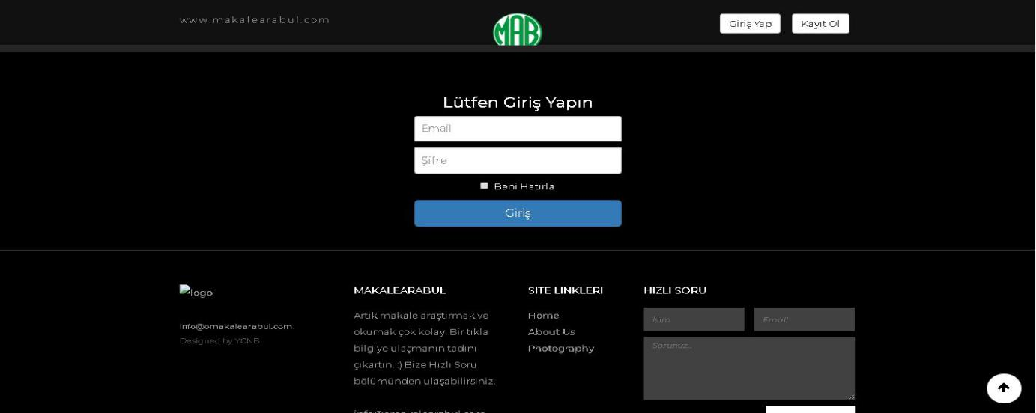

# Figure-1:Authentication Screen

# The detailed description of items of authentication screen:

# Name of item: Email text box.

Description of purpose: To enter the email of the user for whom authentication to the Article shall be given.

Source of input: Keyboard.

Valid range: The email shall be minumum 10 characters

Units of measure: -

Timing: -

Relationship to other inputs: -

Screen formats/organization: As seen in Figure 1. Window formats/organization: -

Data formats: -

Command formats: -

End messages: -

# Name of item: Password text box.

Description of purpose: To enter the password of the user for whom authentication to the Article System shall be given.

Source of input: Keyboard.

Valid range:The password shall be maximum 8 characters long and cannot be zero

Units of measure: -

Timing: -

Relationship to other inputs: -

Screen formats/organization: As seen in Figure 1. Window formats/organization: -

Data formats: The password shall consist of alphanumeric characters only and shall be compatible with ISO 8859-1 character set

Command formats: -

End messages: -

**3.Name of item: Giris button**

Description of purpose: : To send the entered inputs to the server software.

Source of input: Keyboard or mouse

Valid range-

Units of measure: -

Timing: -

Relationship to other inputs: The email and password of the user shall be entered in the user-id text box and password text box respectively before initiating authentication functionality

Screen formats/organization: As seen in Figure 1. Window formats/organization: -

Data formats: -

Command formats: -

End messages: -

**4.Name of item: BeniHatırla Checkbox**

Description of purpose: :For convenience when logged in.

Source of input: Mouse

Valid range-

Units of measure: -

Timing: -

Relationship to other inputs: -

Screen formats/organization: As seen in Figure 1. Window formats/organization: -

Data formats: -

Command formats: -

End messages: -

**5.Name of item: Kayıtol Button**

Description of purpose: :Redirects registration plan

Source of input: Mouse

Valid range-

Units of measure: -

Timing: -

Relationship to other inputs: From this interface, the identity to continue the registration is chosen and the corresponding registration page can be reached.

Screen formats/organization: As seen in Figure 1. Window formats/organization: -

Data formats: -

Command formats: -

End messages: -

**6.Name of item:İsim Textbox**

Description of purpose: :Name of user

Source of input: Keyboard

Valid range-

Units of measure: -

Timing: -

Relationship to other inputs:-

Screen formats/organization: As seen in Figure 1. Window formats/organization: -

Data formats: -

Command formats: -

End messages: -

**7.Name of item: Sorunuz_ Textbox**

Description of purpose: To ask questions.

Source of input: Keyboard

Valid range-

Units of measure: -

Timing: -

Relationship to other inputs:

Screen formats/organization: As seen in Figure 1. Window formats/organization: -

Data formats: -

Command formats: -

End messages: -

# 3.1.1.2 Main Registration Page

The Article SYSTEM shall register user to enter to the system.

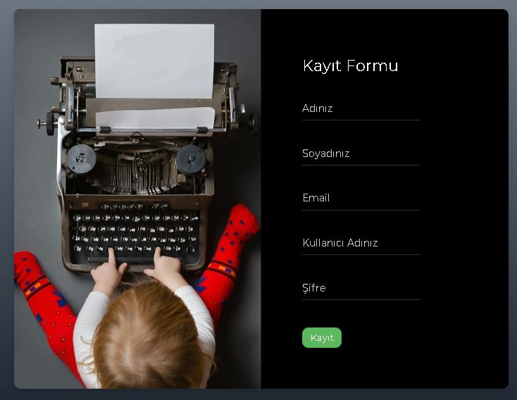

**Figure-2:** Register

**1.Name of item: Adınız_ Textbox**

Description of purpose: To ask name.

Source of input: Keyboard

Valid range-

Units of measure: -

Timing: -

Relationship to other inputs:

Screen formats/organization: As seen in Figure 2. Window formats/organization: -

Data formats: -

Command formats: -

End messages: -

**2..Name of item: Soyadınız_ Textbox**

Description of purpose: Enter surname for the system.

Source of input: Keyboard

Valid range-

Units of measure: -

Timing: -

Relationship to other inputs:

Screen formats/organization: As seen in Figure 2. Window formats/organization: -

Data formats: -

Command formats: -

End messages: -

**3.Name of item: Email_ Textbox**

Description of purpose: To enter the email of the user for whom authentication to the Article shall be given.

Source of input: Keyboard.

Valid range: The email shall be minumum 10 characters

Units of measure: -

Timing: -

Relationship to other inputs: -

Screen formats/organization: As seen in Figure 1. Window formats/organization: -

Data formats: -

Command formats: -

End messages: -

**4.Name of item: Kullanıcıadınız_ Textbox**

Description of purpose: To ask nickname.

Source of input: Keyboard

Valid range :-

Units of measure: -

Timing: -

Relationship to other inputs:

Screen formats/organization: As seen in Figure 2. Window formats/organization: -

Data formats: -

Command formats: -

End messages: -

**5.Name of item: Sifre_ Textbox**

Description of purpose: To enter the password of the user for whom authentication to the Article System shall be given.

Source of input: Keyboard.

Valid range:The password shall be maximum 8 characters long and cannot be zero

Units of measure: -

Timing: -

Relationship to other inputs: -

Screen formats/organization: As seen in Figure 2. Window formats/organization: -

Data formats: The password shall consist of alphanumeric characters only and shall be compatible with ISO 8859-1 character set

Command formats: -

End messages: -

**6.Name of item: Kayıt_Button**

Description of purpose: :Redirects registration plan

Source of input: Mouse

Valid range-

Units of measure: -

Timing: -

Relationship to other inputs: From this interface, the identity to continue the registration is chosen and the corresponding registration page can be reached.

Screen formats/organization: As seen in Figure 2. Window formats/organization: -

Data formats: -

Command formats: -

End messages: -

# 3.1.1.3 ALL USER MAİNPAGE



# Figure-3:Mainpage

**1.Name of item: MakaleArama_**

Description of purpose: You search for articles.

Source of input: Keyboard.

Valid range:-

Units of measure: -

Timing: -

Relationship to other inputs: -

Screen formats/organization: As seen in Figure 3. Window formats/organization: -

Data formats: The reviewie arama textbox shall consist of alphanumeric characters only and shall be compatible with ISO 8859-1 character set Command formats: -

End messages: -

**2.Name of item: All_Button**

Description of purpose: :Show all the articles

Source of input: Mouse

Valid range-

Units of measure: -

Timing: -

Relationship to other inputs: From this interface, continue the article is chosen and the corresponding article page can be reached.

Screen formats/organization: As seen in Figure 3. Window formats/organization: -

Data formats: -

Command formats: -

End messages: -

**3.Name of item: PORTARITS_Button**

Description of purpose: :Show portarıts.

Source of input: Mouse

Valid range-

Units of measure: -

Timing: -

Relationship to other inputs:This article has reached the text.

Screen formats/organization: As seen in Figure 3. Window formats/organization: -

Data formats: -

Command formats: -

End messages: -

# 3.1.1.4 WRİTER&ADMİN MAİNPAGE



**Figure-4:** Writer&Admin Mainpage

**1.Name of item: MakaleEkle_Button**

Description of purpose: Redirects to article insertion page

Source of input: Mouse

Valid range-

Units of measure: -

Timing: -

Relationship to other inputs:From this interface, continue the portarıts is chosen and the corresponding portarıts page can be reached.

Screen formats/organization: As seen in Figure 4. Window formats/organization: -

Data formats: -

Command formats: -

End messages: -

# 3.1.1.5 Add Article

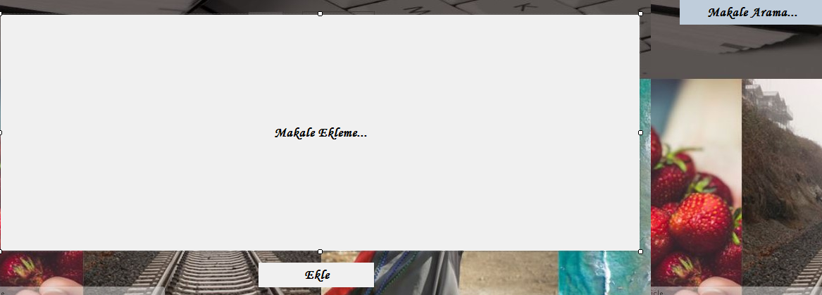

**Figure-5:**Add Article

**1.Name of item: MakaleEkle_TextBox**

Description of purpose: To add an article

Source of input:Keyboard

Valid range-

Units of measure: -

Timing: -

Relationship to other inputs:-

Screen formats/organization: As seen in Figure 5. Window formats/organization: -

Data formats: -

Command formats: -

End messages: -

**2.Name of item: Ekle_Button**

Description of purpose: Send to an article

Source of input:Keyboard& Mouse

Valid range-

Units of measure: -

Timing: -

Relationship to other inputs:-

Screen formats/organization: As seen in Figure 5. Window formats/organization: -

Data formats: -

Command formats: -

End messages: -

# 3.1.1.5 Add Comment



**Figure-6:** Add Comment

**1.Name of item:YorumYaz_TextBox**

Description of purpose: For write Comment

Source of input:Keyboard& Mouse

Valid range-

Units of measure: -

Timing: -

Relationship to other inputs:-

Screen formats/organization: As seen in Figure 6. Window formats/organization: -

Data formats: -

Command formats: -

End messages: -

**2.Name of item:Gönder_Button**

Description of purpose: To post Comments

Source of input:Keyboard& Mouse

Valid range-

Units of measure: -

Timing: -

Relationship to other inputs:-

Screen formats/organization: As seen in Figure 6. Window formats/organization: -

Data formats: -

Command formats: -

End messages: -

# 3.1.1.6 Approval Comment

Admin approvals comment

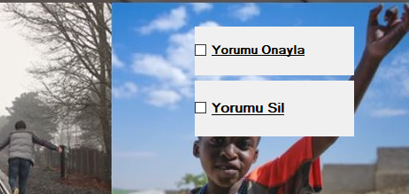

**Figure-7:** Approval Comment

**1.Name of item:YORUMUSİL_CheckBox**

Description of purpose: To delete comment

Source of input:Keyboard& Mouse

Valid range-

Units of measure: -

Timing: -

Relationship to other inputs:-

Screen formats/organization: As seen in Figure 7. Window formats/organization: -

Data formats: -

Command formats: -

End messages: -

**1.Name of item:YORUMUONAYLA_CheckBox**

Description of purpose: To approval comment

Source of input:Keyboard& Mouse

Valid range-

Units of measure: -

Timing: -

Relationship to other inputs:-

Screen formats/organization: As seen in Figure 7. Window formats/organization: -

Data formats: -

Command formats: -

End messages: -

## Functions:

### Common Functions for All Users

# 

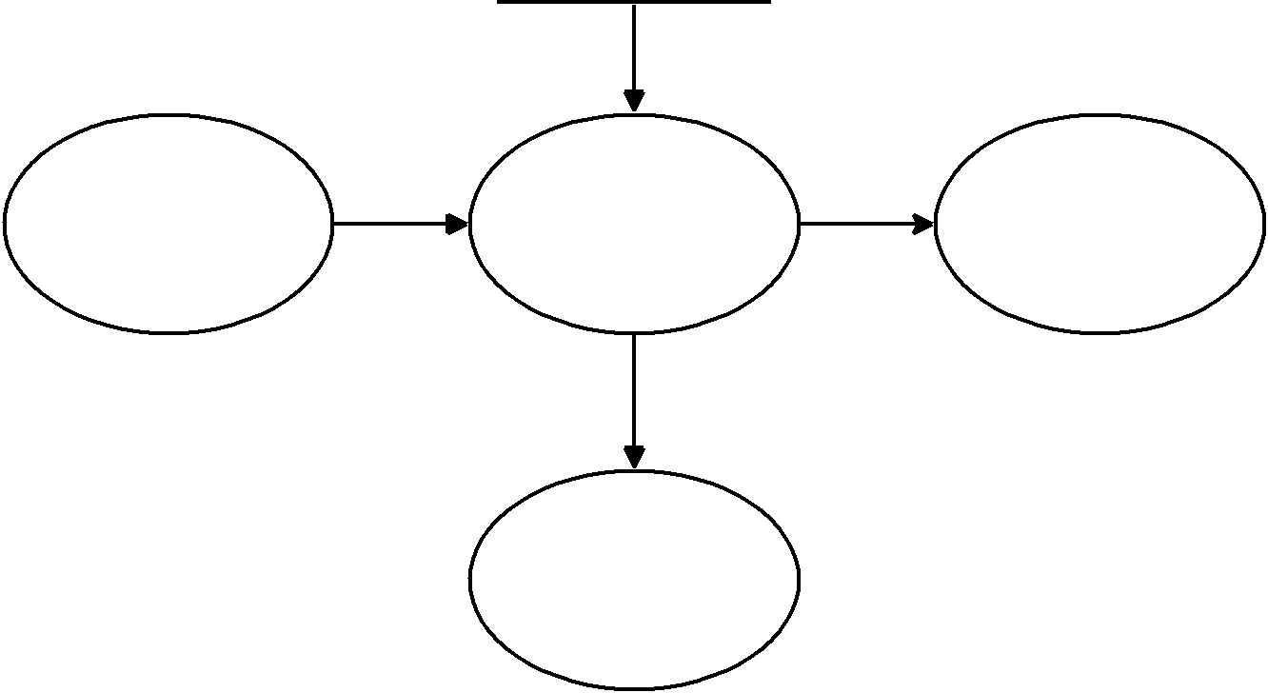 Read access user information file

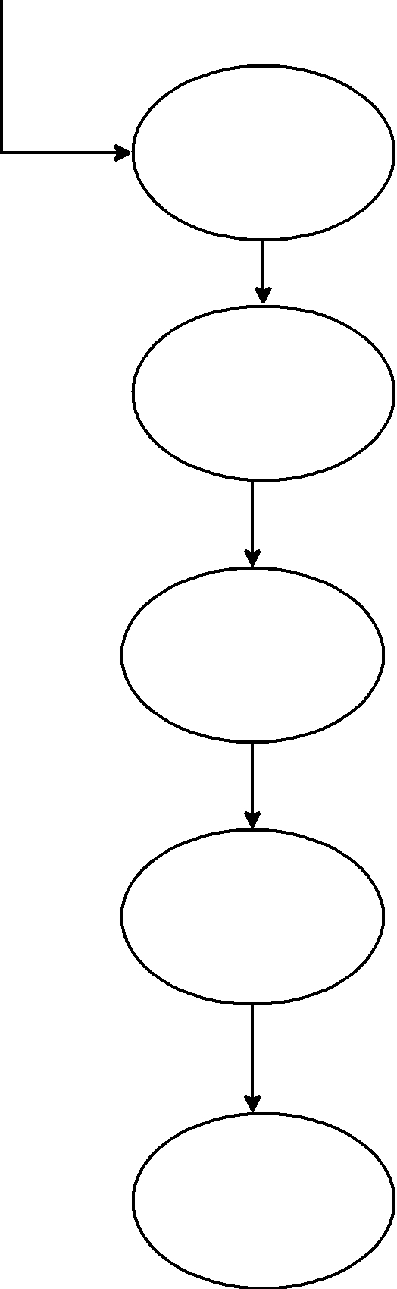 to articles

All USERS

Write Comments Member Login Enter emai**l** Commentable



And password

Register

Enter email and password Display error message

Save email and password

Display Succes message

**Figure-8 :** DFD For All Users

### Common Functions for Admin

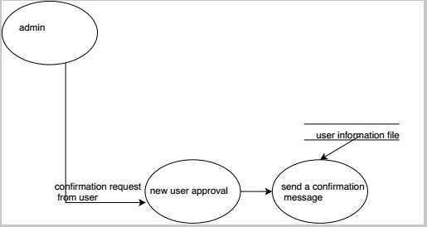

**Figure-9:** DFD For Admin Common Function

#### Add&Delete Article

#### gfd

**Figure-10:** DFD For Admin Adding and Deleting Article

#### DELETE USER

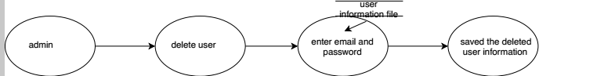

**Figure-11:** DFD For Admin Deleting Users

## Performance Requirements:

• The system response time shall be maximum 15 seconds in the 100 mbit LAN environment.

## Logical Database Requirements

Our customer will give the database that store firms detailed information.

## Design Constraints

The ARTICLE SYSTEM standard compliance requirements are as follows:

### Standards Compliance

The ARTICLE SYSTEM standard compliance requirements are as follows: Any kind of documentation prepared for ION-CHAT SYSTEM shall be in content compliance with IEEE standards [7, 8, 9, 10].

## Software System Attributes

### Reliability

• Total number of bugs in the system shall not exceed %2 of the total lines of code.

### Availability

• System shall be restarted in 30 seconds when the system crash occurs.

### Security

• There is no security issue. Passwords will be in plain format.

• Communication will not be encrypted between the client and the server

### Maintainability

• AS Software will be developed using object oriented programming approach and using C# development language. Each and every module will be explicitly defined and documented.

### Portability

The ARTICLE SYSTEM shall be a platform independent system, provided that..